Trinity Sunday
Sunday, June 16, 2019
Welcome! Please sign the red attendance pad as it passes down your pew. If you are a first-time visitor, please complete a yellow card and drop in the offering plate. For prayer requests, simply complete a blue card and place it in the offering plate for inclusion in today’s Pastoral Prayer.

Order of Worship

Welcome & Announcements Celene Terry

*Passing of the Peace ”The Family of God” Celene Terry

The Chiming of the Hour and Procession of the Acolyte

*Call to Worship “Holy Ground” TFWS 2272

*Scripture Reading Proverbs 8:1-4 Celene Terry

*Hymn “Here I Am, Lord” UMH 593

*Offertory Prayer Celene Terry

Offertory

*Doxology UMH 95

Pastoral Prayer/The Lord’s Prayer Rev. Dan Gurley

Pastor’s Pals Rev. Gurley

*Apostles’ Creed Celene Terry UMH 881

*Gloria Patri UMH 70

*Hymn “Blessed Assurance” UMH 369

Anthem

*Scripture Reading & Prayer Romans 8:28 Rev. Gurley

Message Rev. Gurley

*Hymn of Invitation “Pass Me Not, O Gentle Savior” UMH 351

*Benediction Rev. Gurley

*Benediction Song “Since Jesus Came into My Heart” TFWS 2140 refrain

*Postlude

*Stand if able: UMH=United Methodist Hymnal, TFWS=The Faith We Sing.
Nurture Therefore encourage one another and build up one another, just as you also are doing. --1 Thessalonians 5:11

New Prayers: Continued Prayers:

Our Church  Linda Kuykendall  Becky Kay  Ronald Gladwell  Alice West  Jasmine Jones  Debbie Wrinkle McAllister  Sympathy:  Family and friends of Wendy Spangler | Wyatt Alexander,  Mary Bonsal,  Greta Boultinghouse,  Jack Brandy,  Sammy Coleman,  Bill Cross,  Barbara Hamilton,  Mary Henderson,  Skyler Hicks,  Dana Hunter,  Becky Keele,  Virginia Lane,  Willie Lundy,  Paulette Martin,  Suzie McCarthy,  Rev. Ella McDonald,  John McMillian,  Mary McNinch,  Janson Morgan,  Matthew Mutz,  Sherry Nash,  Whitney Nunn,  Lyndon & Beverly Patrick,  Jordan Toon, Dee & Don Trull, John White, and Meredith Williams. | Angels In The Wings:  Adda Beamgard Gladys Caulking  Patrick Fremming Mary Friedel Loretta Hamilton Jessie Kelley  Benita King  Mary Jo Lemons Pam Long Shirley Menasco  Betty Pollock  Charlotte Reppen  Cynthia Van Pelt-Sperry Pat Underriner Peggy Whisenant

Financial Report: January-May 2019 Income: $282,163.68
Expense: ($214,011.03)

Don’t Forget….
You can give/tithe online through FUMCMabank.com.

Visit our Serve tab and click on the
Serve Through Giving page.

Or visit: https://www.fumcmabank.com/serve/serve-through-giving/
Church Staff:
Senior Pastor: Rev. Dan Gurley
dan@fumcmabank.com

Custodian: Kim Grimes

Director of Communications: Kelly Sasenbery
kelly@fumcmabank.com

Director of Music Ministries: Aaron Strum
aaron@fumcmabank.com

Financial Administrator: Rhonda Jones
rhonda@fumcmabank.com

Nursery Attendants: Yolanda & Carolyn Jimenez

Office Administrator & Pianist: Lance Douglas Gutierrez
lance@fumcmabank.com

Organist: Janice Sutton

Student Ministries Director: Olivia Pannell
olivia@fumcmabank.com

Church Hours:
Monday - Thursday: 9:00 a.m. – 3:00 p.m.
Friday & Saturday: Closed

Helping Hands Desk:
Tuesday – Thursday
9:00 - 11:00 a.m. – 1:00 - 3:00 p.m.

Sunday Schedule:
Sunday School at 9:00 a.m. for all ages.
Worship at 10:00 a.m.

*Holy Communion is shared on the 1st Sunday of each month.
On all other Sundays, communion is available in the Wesley Chapel immediately after service.

Ⓒ2019 FUMC Mabank, All rights reserved. CCLI #183424

Would you like to know more about Jesus Christ, how to become a Christian or would like more information about church membership? Perhaps you just need
someone to pray with or talk to you. Please let us know!

June 16, 2019
10:00 a.m. Worship Service.

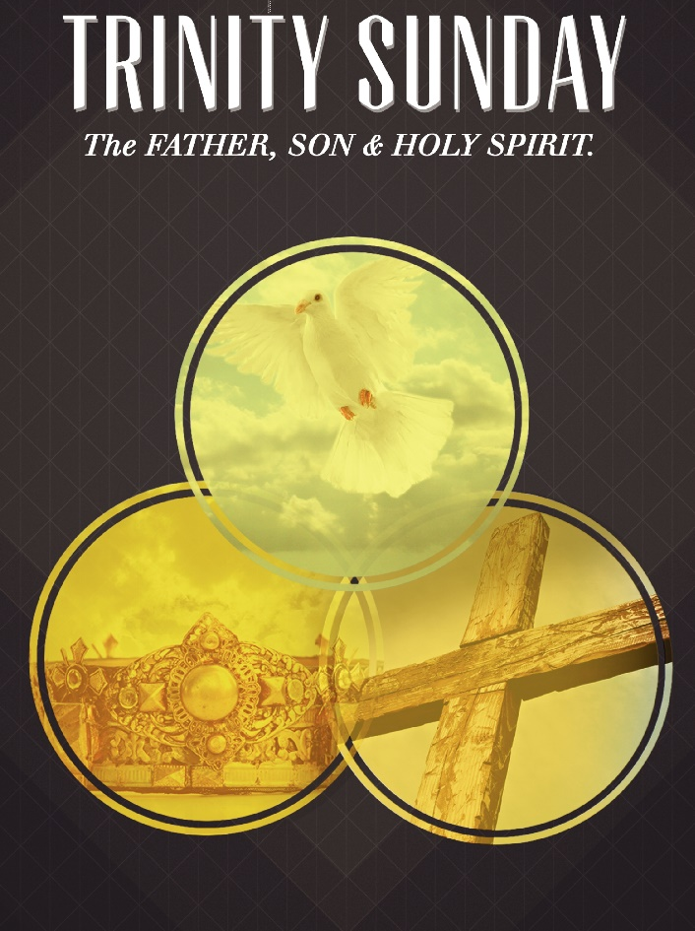

First United Methodist Church of Mabank, TX
501 South Third Street
Mabank, TX 75147

Phone: 903-887-3691 Fax: 903-887-0670
www.fumcmabank.com

