23rd Sunday after Pentecost
Sunday, November 17, 2019
Welcome! Please sign the red attendance pad as it passes down your pew.
If you are a first-time visitor, please complete a yellow card and drop in the offering plate. For prayer requests, simply complete a blue card and place it in the offering plate for
inclusion in today’s Pastoral Prayer.

Order of Worship

Welcome & Announcements Celene Terry

*Passing of the Peace ”God’s Wonderful People” Celene Terry

The Chiming of the Hour and Procession of the Acolyte

*Call to Worship “God Is Here” UMH 660 vs. 1

Scripture Reading 2 Thessalonians 3:6-13 Celene Terry

*Hymn “O For A Thousand Tongues To Sing” UMH 57

*Offertory Prayer Celene Terry

Offertory

*Doxology UMH 95

Pastoral Prayer/The Lord’s Prayer Rev. Dan Gurley

Baptism of Christian Elijah Rubio UMH 39 Rev. Gurley

Apostles’ Creed UMH 881 Celene Terry

Gloria Patri UMH 70

*Hymn ”We Gather Together” UMH 131

Special Music Jubilation 5

*Scripture Reading & Prayer John 8:1-11 Rev. Gurley

Message Rev. Gurley

*Hymn of Invitation “Near to the Heart of God” UMH 472 vs. 1-2

*Benediction Rev. Gurley

*Postlude

*Stand if able: UMH=United Methodist Hymnal, TFWS=The Faith We Sing.

Nurture Therefore encourage one another and build up one another, just as you also are doing. --1 Thessalonians 5:11

New Prayers: Continued Prayers:

Our Church  Heather Graham  James Jones  Baby Kye Smith  Vicki Allen  Ralaine Manning  Joaquin Bejarand  Stuart Weatherford  Joe Pickens  Tony Boyd  John White  Glenda Dawson  Levi  Mary Smith  Sympathy:  Family and friends of Doris Parker. | Diane Ackles,  Wyatt Alexander,  Greta Boultinghouse,  Ray Bourre,  Jack Brandy,  Kelly Chancellor,  Sammy Coleman,  Bill Cross, Chris Ensley,  Barbara Hamilton, Matt Herron,  Curtis Himes, Jean Hyde,  Kelli Janway, Madison Jordon, Becky Keele, Levon Kristmer, Virginia Lane, Linda Maldonado,  Paulette Martin,  Rev. Ella McDonald,  John McMillian,  Rhonda Morgan,  Sherry Nash,  John Otto,  Lee Perkins,  Matthew Rabone,  Clara Ries,  Donnie Roberts,  Scott Smith,  Jim Starrett,  Dee & Don Trull,  and T.J. Wiersgalla. | Angel’s In The Wings:  Adda Beamgard  Mary Bonsal Gladys Caulking  Mary Friedel  Tommy Jobe  Jessie Kelley  Benita King  Linda Kuykendall  Mary Jo Lemons Pam Long  Knox Lowe Shirley Menasco  Betty Pollock  Charlotte Reppen  Cynthia Van Pelt-Sperry Pat Underriner Peggy Whisenant

Financial Report: January-October 2019 Income: $490,043.37
Expense: ($452,198.83)

Don’t Forget….
You can give/tithe online through FUMCMabank.com.

Visit our Serve tab and click on the
Serve Through Giving page.

Or visit: https://www.fumcmabank.com/serve/serve-through-giving/
Church Staff:
Senior Pastor: Rev. Dan Gurley
dan@fumcmabank.com

Foundry House Ministries: Rev. Allison Partridge

Custodian: Kim Grimes

Director of Communications: Kelly Sasenbery
kelly@fumcmabank.com

Director of Music Ministries: Aaron Strum
aaron@fumcmabank.com

Financial Administrator: Rhonda Jones
rhonda@fumcmabank.com

Nursery Attendants: Yolanda & Carolyn Jimenez

Office Administrator & Pianist: Lance Douglas Gutierrez
lance@fumcmabank.com

Organist: Janice Sutton

Director of Children Ministries: Linda Jackson

Director of Youth Ministries: Olivia Pannell
olivia@fumcmabank.com

Church Hours:
Monday - Thursday: 9:00 a.m. – 3:00 p.m.
Friday & Saturday: Closed

Helping Hands Desk:
Tuesday – Thursday
9:00 - 11:00 a.m. – 1:00 - 3:00 p.m.

Sunday Schedule:
Sunday School at 9:00 a.m. for all ages.
Worship at 10:00 a.m.

*Holy Communion is shared on the 1st Sunday of each month unless noted otherwise. On the third Sunday, communion is available in the Wesley Chapel immediately after service.

Ⓒ2019 FUMC Mabank, All rights reserved. CCLI #183424

Would you like to know more about Jesus Christ, how to become a Christian or would like more information about church membership? Perhaps you just need
someone to pray with or talk to you. Please let us know!

November 17, 2019
23rd Sunday after Pentecost

10:00 a.m. Worship Service
Rev. Dan Gurley

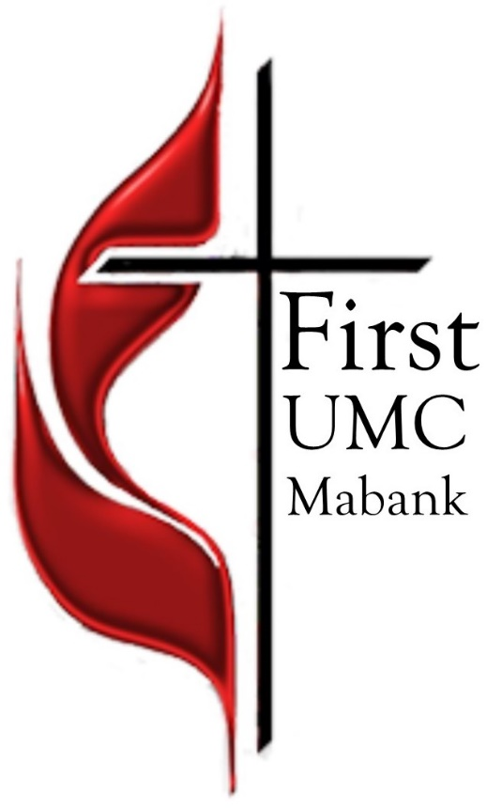

First United Methodist Church
501 South Third Street
Mabank, TX 75147

Phone: 903-887-3691 Fax: 903-887-0670
www.fumcmabank.com

