First Sunday of Advent and Hanging of the Greens
Sunday, December 1, 2019

Welcome! Please sign the red attendance pad as it passes down your pew.
If you are a first-time visitor, please complete a yellow card and drop in the offering plate. For prayer requests, simply complete a blue card and place it in the offering plate for
inclusion in today’s Pastoral Prayer.

Order of Worship

Welcome & Announcements Sally Simon

*Passing of the Peace ”God’s Wonderful People” Sally Simon

The Chiming of the Hour and Procession of the Acolyte

*Call to Worship “Emmanuel, Emmanuel” UMH 204

The Hanging of the Greens Linda Jackson *See Insert

Lighting of the Advent Candle The Ahrens Family

*Hymn “O Come, O Come, Emmanuel” UMH 211

*Offertory Prayer Sally Simon

Offertory

*Doxology UMH 95

Pastoral Prayer Rev. Dan Gurley

Children’s Time Chrismon Reading

*Hymn ”O Come, All Ye Faithful” UMH 234

Anthem “Go Tell It on the Mountain” Chancel Choir

*Scripture Reading & Prayer Matthew 24:36-44 Rev. Gurley

Message Rev. Gurley

Prayer of Confession/Communion/The Lord’s Prayer Rev. Gurley

*Hymn of Invitation “Away in a Manger” UMH 217 vs. 1-2

*Benediction Rev. Gurley

*Postlude

*Stand if able: UMH=United Methodist Hymnal, TFWS=The Faith We Sing.

Nurture Therefore encourage one another and build up one another, just as you also are doing. --1 Thessalonians 5:11

New Prayers: Continued Prayers:

Our Church  Jean Morrow  Matt Herron  Bill Morgan  Nelda Burney  Bobby Reed  Ruby Snow  Jaci Johnson  Jessica Mae  Mary Allen  Annie Garnica  Cathy Hughes  Barbara & Mark Joles | Diane Ackles,  Wyatt Alexander,  Joaquin Bejarand,  Greta Boultinghouse,  Ray Bourre, Tony Boyd,  Jack Brandy, Kelly Chancellor,  Sammy Coleman,  Bill Cross, Chris Ensley,  Barbara Hamilton,  Curtis Himes, Jean Hyde,  Kelli Janway, James Jones, Madison Jordon, Becky Keele, Levon Kristmer, Virginia Lane, Paulette Martin,  Rev. Ella McDonald,  John McMillian,  Rhonda Morgan,  Sherry Nash,  John Otto, Lyndon Patrick,  Lee Perkins, Joe Pickens,  Matthew Rabone,  Clara Ries, Donnie Roberts,  Mary Smith, Kye Smith, Scott Smith,  Jim Starrett, Dee & Don Trull,  John White, Stuart Weatherford,  and T.J. Wiersgalla. | Angel’s In The Wings:  Adda Beamgard  Mary Bonsal Gladys Caulking  Mary Friedel  Tommy Jobe  Jessie Kelley  Benita King  Linda Kuykendall  Mary Jo Lemons Pam Long  Knox Lowe Shirley Menasco  Betty Pollock  Charlotte Reppen  Cynthia Van Pelt-Sperry Pat Underriner Peggy Whisenant

Financial Report: January-October 2019 Income: $490,043.37
Expense: ($452,198.83)

Don’t Forget….
You can give/tithe online through FUMCMabank.com.

Visit our Serve tab and click on the
Serve Through Giving page.

Or visit: https://www.fumcmabank.com/serve/serve-through-giving/
Church Staff:
Senior Pastor: Rev. Dan Gurley
dan@fumcmabank.com

Foundry House Ministries: Rev. Allison Partridge

Custodian: Kim Grimes

Director of Communications: Kelly Sasenbery
kelly@fumcmabank.com

Director of Music Ministries: Aaron Strum
aaron@fumcmabank.com

Financial Administrator: Rhonda Jones
rhonda@fumcmabank.com

Nursery Attendants: Yolanda & Carolyn Jimenez

Office Administrator & Pianist: Lance Douglas Gutierrez
lance@fumcmabank.com

Organist: Janice Sutton

Director of Children’s Ministries: Linda Jackson

Director of Youth Ministries: Olivia Pannell
olivia@fumcmabank.com

Church Hours:
Monday - Thursday: 9:00 a.m. – 3:00 p.m.
Friday & Saturday: Closed

Helping Hands Desk:
Tuesday – Thursday
9:00 - 11:00 a.m. – 1:00 - 3:00 p.m.

Sunday Schedule:
Sunday School at 9:00 a.m. for all ages.
Worship at 10:00 a.m.

*Holy Communion is shared on the 1st Sunday of each month unless noted otherwise. On the third Sunday, communion is available in the Wesley Chapel immediately after service.

Ⓒ2019 FUMC Mabank, All rights reserved. CCLI #183424

Would you like to know more about Jesus Christ, how to become a Christian or would like more information about church membership? Perhaps you just need
someone to pray with or talk to you. Please let us know!

December 1, 2019
1st Sunday of Advent

10:00 a.m. Worship Service with Communion.
Rev. Dan Gurley

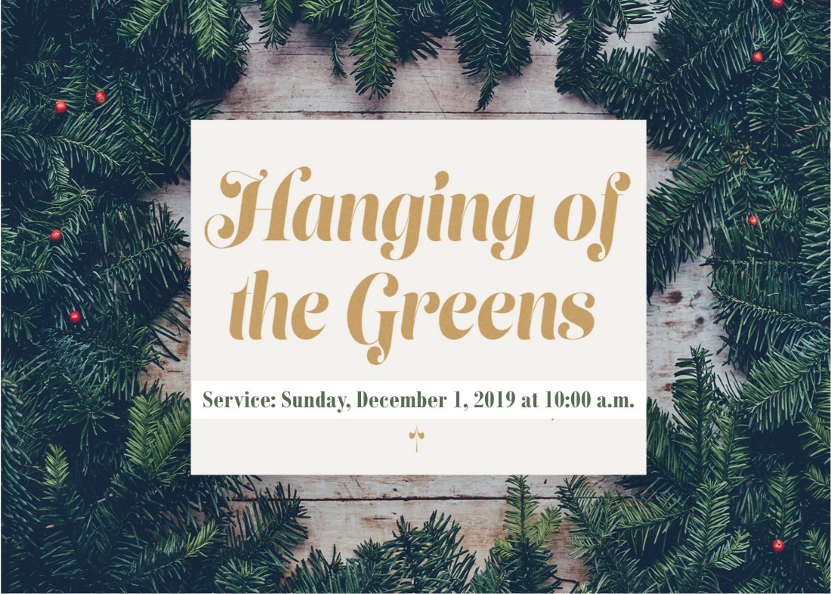

First United Methodist Church
501 South Third Street
Mabank, TX 75147

Phone: 903-887-3691 Fax: 903-887-0670
www.fumcmabank.com

