Second Sunday in Lent and Girl Scout Sunday
Sunday, March 8, 2020

Welcome! Please sign the red attendance pad as it passes down your pew.
If you are a first-time visitor, please complete a yellow card and drop in the offering plate. For prayer requests, simply complete a blue card and place it in the offering plate for
inclusion in today’s Pastoral Prayer.

*The fresh flowers are in memory of Ruth Boswell.

Order of Worship

Welcome & Announcements Linda Jackson

*Passing of the Peace Linda Jackson

The Chiming of the Hour and Procession of the Acolyte

*Call to Worship “Were You There” UMH 288

*Scripture Reading Romans 4:1-8 Linda Jackson

*Hymn “O How I Love Jesus” UMH 170

*Offertory Prayer Linda Jackson

Offertory “You Are My All in All” Jubilation 5

*Doxology UMH 95

Pastoral Prayer/The Lord’s Prayer Rev. Dan Gurley

Pastor’s Pals Rev. Gurley

*Apostles’ Creed Linda Jackson

*Gloria Patri

*Hymn ”In Christ Alone” See Screens

Anthem ”O Love” Chancel Choir

*Scripture Reading & Prayer Mark 5:24-34 Rev. Gurley

Message Rev. Gurley

*Hymn of Invitation “Just as I Am, Without One Plea” UMH 357

*Benediction Rev. Gurley

*Postlude

*Stand if able: UMH=United Methodist Hymnal, TFWS=The Faith We Sing.

Nurture Therefore encourage one another and build up one another, just as you also are doing. --1 Thessalonians 5:11

New Prayers: Continued Prayers:

Our Church  Linda Belssner  Anthony Gayton  Deen Wier  Ruth Wilson  Lisa & Brian Booth  Leola & Annie Garnica  DeEsta  Rose Giordano  and family  Sympathy:  Family and friends of Ruth Boswell.  Family of Merrilee Craven McLemore.  Family and friends of Ronnie Gartrell. | Diane Ackles,  James Adams,  Wyatt Alexander, Bob Allen,  Alice Barker, Paula Beamis,  Joaquin Bejarano, Melissa Berger,  Chris Bonsal, Greta Boultinghouse, Ray Bourre, Joe Boyd, Jack Brandy,  Rhonda Brooks, Kelly Chancellor, Sue Cohn, Sammy Coleman,  Bill Cross, Pat Davis, Terry Evans, Chris Ensley ,Matt Herron,  Curtis Himes, Trey Holthy,  Wendy Horton, Cathy Hughes,  Susie Hull, Jean Hyde, Kelli Janway,  Madison Jordon, Becky Keele,  Levon Kristmer, Virginia Lane,  Paulette Martin, Rev. Ella McDonald,  John McMillian, Rhonda Morgan  Jean Morrow, Sherry Nash,  Mitch Orr, John Otto,  Walter Reaves, Clara Ries,  Donnie Roberts, Sally Simon,  Mary Smith, Scott Smith,  Patsy Speer, Jim Starrett,  Ethan Toler, Dee & Don Trull, Melinda Van Horn,  and T.J. Wiersgalla. | Angels In The Wings:  Adda Beamgard  Gladys Caulking  Mary Friedel  Tommy Jobe  Jessie Kelley  Benita King  Linda Kuykendall  Mary Jo Lemons Pam Long  Knox Lowe Shirley Menasco  Betty Pollock  Charlotte Reppen  Cynthia Sperry Pat Underriner Peggy Whisenant

Financial Report: January- February 2020 Income: $91,454.39
Expense: ($112,559.69)

Don’t Forget….
You can give/tithe online through FUMCMabank.com.

Visit our Serve tab and click on the
Serve Through Giving page.

Or visit: https://www.fumcmabank.com/serve/serve-through-giving/
Church Staff:
Senior Pastor: Rev. Dan Gurley
dan@fumcmabank.com

Foundry House Ministries: Rev. Allison Partridge

Custodian: Kim Grimes

Director of Communications: Kelly Sasenbery
kelly@fumcmabank.com

Director of Music Ministries: Aaron Strum
aaron@fumcmabank.com

Financial Administrator: Rhonda Jones
rhonda@fumcmabank.com

Nursery Attendants: Yolanda & Carolyn Jimenez

Office Administrator & Pianist: Lance Douglas Gutierrez
lance@fumcmabank.com

Organist: Janice Sutton

Director of Children’s Ministries: Linda Jackson

Director of Youth Ministries: Olivia Pannell
olivia@fumcmabank.com

Church Hours:
Monday - Thursday: 9:00 a.m. – 3:00 p.m.
Friday & Saturday: Closed

Helping Hands Desk:
Tuesday – Thursday
9:00 - 11:00 a.m. – 1:00 - 3:00 p.m.

Sunday Schedule:
Sunday School at 9:00 a.m. for all ages.
Worship at 10:00 a.m.

*Holy Communion is shared on the 1st Sunday of each month unless noted otherwise. On the third Sunday, communion is available in the Wesley Chapel immediately after service.

Ⓒ2020 FUMC Mabank, All rights reserved. CCLI #183424

Would you like to know more about Jesus Christ, how to become a Christian or would like more information about church membership? Perhaps you just need
someone to pray with or talk to you. Please let us know!

Sunday, March 8, 2020
Second Sunday in Lent
and Girl Scout Sunday
10:00 a.m. Worship Service.
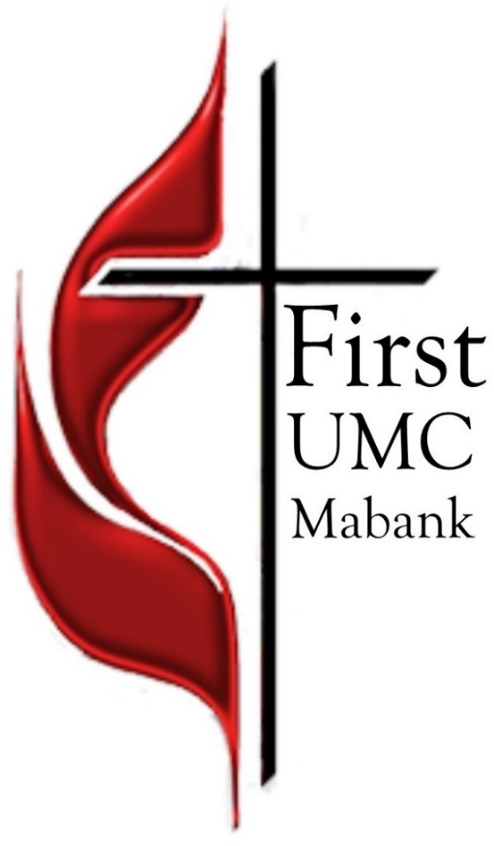

First United Methodist Church
501 South Third Street
Mabank, TX 75147

Phone: 903-887-3691 Fax: 903-887-0670
www.fumcmabank.com

